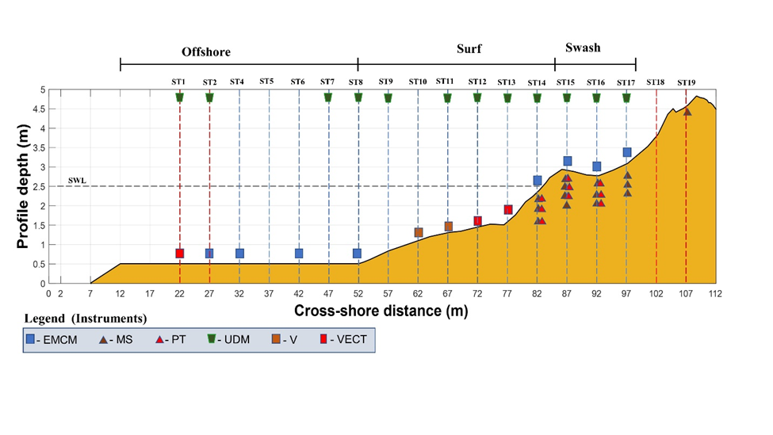

**The scaled beach profile in the INRS wave flume.**